GiveMore - a Donation-Based Community Marketplace for COVID-19

(Team _init_iators - Gaurav S, Roma Pai, Ganga S Nair, Arghya Biswas)

## TEAM DETAILS:

Team name - Team _init_iators

Team Leader - Arghya Biswas

Team Leader’s email - [arghyabiswas2000@gmail.com](mailto:arghyabiswas2000@gmail.com)

## OVERVIEW:

The impact of COVID-19 pandemic has been largely disruptive. The World Bank and rating agencies had initially downgraded India's growth for fiscal year 2021 with the lowest figures India has seen in three decades since India's economic liberalization in the 1990s. Our prototype is a donation-based marketplace for essential supplies that focuses on community cooperation. Through our mobile application donors can donate surplus supplies they have to the financially underprivileged, medical workers and also NGOs and hospitals. Our mobile application is built using the Flutter framework for cross-platform support and we have used Firebase for backend services. The COVID-19 crisis caused millions of people to lose their jobs overnight and unemployment rose from 6.7% on 15 March to 26% on 19 April. To provide temporary employment, we have distributors picking up these supplies from donors and delivering them to the donees. Such a move allows us to create opportunities for the unemployed and also respect principles like social distancing. All the supplies collected from the donors will undergo basic quality assurance and sanitization in our collection units and only then be distributed to the donees. To make our mobile app fully accessible, we have included a virtual assistant who will answer all queries related to COVID that a user might have and also help distributors in navigation.

## PROBLEM STATEMENT:

The COVID-19 pandemic has changed the way work and life happens. Today, nearly 3 billion people around the world are under some form of lockdown. Communities and community-based businesses have been hit the hardest by the pandemic as face-to-face interactions have come to a standstill globally. The sectors most at risk include accommodation and food services, manufacturing, retail, and business and administrative activities.

The [COVID-19 crisis](https://www.ilo.org/global/topics/coronavirus/lang--en/index.htm) is expected to wipe out 6.7% of working hours globally in the second quarter of 2020 – equivalent to 195 million full-time workers. Huge losses are expected across different income groups but especially in upper-middle-income countries like India (7%, 100 million full-time workers). This far exceeds the effects of the 2008-9 financial crisis.

There is a growing interest in enabling communities to cooperate among themselves to solve problems in times like these, whether it's to advertise where supplies are held, offer assistance for collections, or provide other local services like volunteer deliveries. While governments may be rolling out broad programs, cooperation at the local level is usually the most effective way of getting help to where it is most needed. While traditional social media is one way of communicating within a community, this is (by its very design) not locally focused, and often not sufficiently structured to enable rapid discovery of what and where help is needed. With the COVID-19 crisis, we have already seen problems with the local supply of food, equipment, and other supplies.

## PROPOSED WORK/IDEA:

Our goal was to provide a mobile application, along with server-side components, that serves as the basis to build out a community cooperation application that addresses local needs for food, equipment, and resources. This donation-based community marketplace would allow both donors (such as a store or a community member who has produce they can distribute) to make people aware of what they have and donees (the individuals who are hit the hardest by the pandemic) to request those supplies from the donors. Our mobile application also enables hospitals, restaurants and NGOs to request for essential supplies at bulk from donors

Because of the pandemic, more than 81% of the global workforce of 3.3 billion are currently affected by full or partial workplace closures. Worldwide, 2 billion people working in the informal sector (mostly in emerging and developing economies) are particularly at risk. The eventual increase in global unemployment during 2020 will depend substantially on future developments and policy measures. In that light, we also have distributors who will be delivering the essential supplies through non-contact delivery services. Such a move not only allows us to get essential supplies to the people who need it the most while respecting social distancing, but also allows us to create temporary employment for people who have been laid off from their jobs. Keeping public health and safety measures into account, all the essential supplies procured from the donors will undergo basic quality assurance and sanitization in collection units maintained by us and only then to be delivered to the donees by the distributors.

## RELATED WORKS:

As this crisis continues to grip us, several NGOs and unorganized communities are working relentlessly to reach out and provide help to people who need it the most. E-commerce sites like Amazon and Flipkart also had links on their websites to donate for COVID-19 relief, though they are now removed. However, where our prototype fundamentally differs from these services is that almost all of them seek monetary donations. NGOs like K&G IRS COVID Relief Initiative, Care India, UDAY Foundation, YUVA and others accept monetary donations to provide essential supplies and food to the people in need. Our proposed idea aims to directly acquire surplus essential supplies from donors and transfer them to the people who require it. This way a greater number of people will be encouraged to donate considering a lot of them already have surplus essential supplies that they panic-shopped when the lockdown was announced by the Govt. Besides, national-level NGOs operate at a very high level and are often unable to address the issues people are facing on a local level. On the other hand, local communities who operate at grassroot level are unorganized and lack proper inventory management. We aim to tackle both these issues by working at a grassroot level and also providing a technology-oriented solution which is accessible to anyone with a smartphone.

## IBM CLOUD SERVICE:

In our prototype, we have used the IBM Watson Assistant which the users can activate by pressing the icon at the top-left corner of the Home page. Our virtual assistant Rose would answer queries related to COVID-19 that users might have and would also be helping distributors navigate to the pickup and delivery points.

## ARCHITECTURE OVERVIEW:

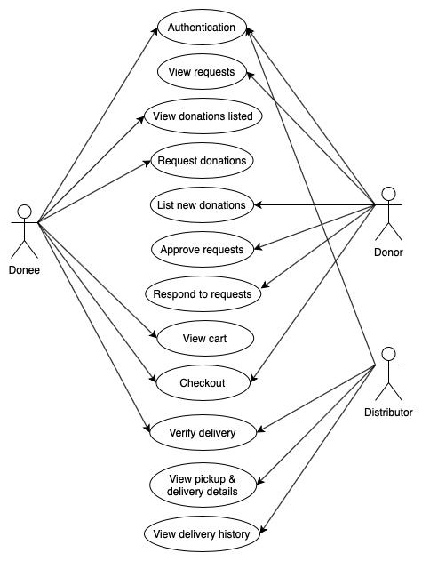

(Use-case diagram of our prototype)

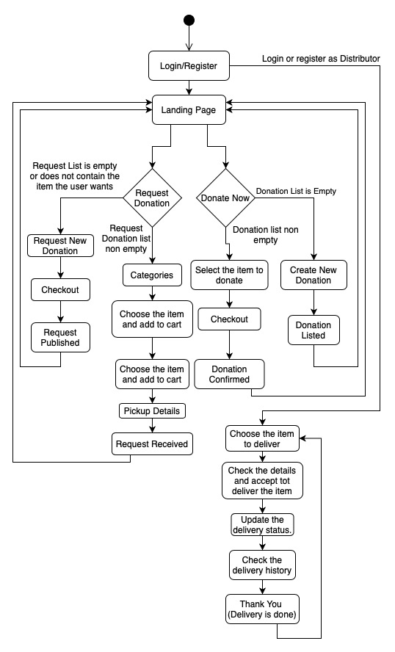

(Activity diagram of our prototype)

## SOLUTION ROADMAP:

Being agile software development enthusiasts, we initially found it difficult to coordinate and communicate amongst ourselves as we are working remotely considering the circumstances. However, version control software like GitHub, conferencing tools like Google Meet and product management services like Trello helped us stay on track and achieve our objectives within the deadline. We used the Kanban methodology for developing our prototype.

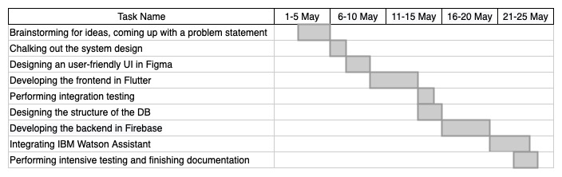

## FUTURE SCOPE:

Though we accomplished all the goals that we set for ourselves while developing this prototype, it is far from a finished product, ready to be launched. Few features that we want to implement in the future are :

1. We have developed this prototype to combat the COVID-19. However, donation-based community marketplaces like this can also be beneficial during times of natural calamities and economic crises.
2. As of now our prototype is a completely donation based system. However, in the future people can also sell their surplus essential supplies at heavy rebate on the MRPs for the financially underprivileged.
3. Since our product is completely donation based, we can implement a rewards system to encourage more donations. Donors will be earning points depending on the frequency, quantity and desirability of donations made which can then be cashed out for gift vouchers from different e-commerce vendors.
4. We are planning to implement an AI classifier to generate Tags from the Title and Image of the donations so that the donor doesn’t have to input the same manually.

Launching a product like this also means having an efficient business model and sustainability plan for the product. Since we, the founders, are not expecting to make a profit out of this product, our only source of expenditures would be salaries of the distributors and the staff working at our collection units and the maintenance cost of running operations in the collection units (quality assurance and sanitization of supplies). For those expenditures, as of now we are relying on sponsors and in-app ads.